**ASSIGNMENT – 9**

Report by Bhavana Sree Naidu Yeluri

**Contents**

1. Project Overview
2. Updated Features
3. Frontend Screenshots
   1. Landing page
   2. Flight Search
   3. Admin Dashboard
   4. Add inventory
   5. User Dashboard
   6. Booking
   7. Change password
   8. Password Validations
   9. Cancellation
   10. Register
   11. Login
   12. Logout
   13. Validations
4. System Architecture
5. Eureka Dashboard
6. Docker
7. MongoDB Screenshots
8. Postman Screenshots
9. Email Notification
10. Message Broker – RabbitMQ
11. SonarQube
12. Jacoco
13. Jmeter
14. Newman
15. Swagger
16. Config Server

**Project Overview**

* + Developed a responsive **Angular-based frontend** for a flight booking platform.
  + Implemented **user authentication flows** including login and registration with **JWT**-based session handling.
  + Built **flight search, booking history, and admin inventory**.
  + Integrated **role-based navigation** to redirect users and admins to appropriate pages.
  + Used **HTTP interceptors** for automatic Bearer token attachment to secured API requests.

**Updated Features**

* Implemented Add flights functionality
* Implemented Role-based Access Control – only admins can add flights
* Used two properties files – one for local and one for docker
* Optimised Docker files
* Implemented change password functionality
* Enforced the user to follow secure password policies
  + Length: Minimum 12 characters, encourage 15+.
  + Complexity: Mix of uppercase, lowercase, numbers, and special characters (though NIST emphasizes length over complexity rules).

**Frontend Screenshots**

* Landing page

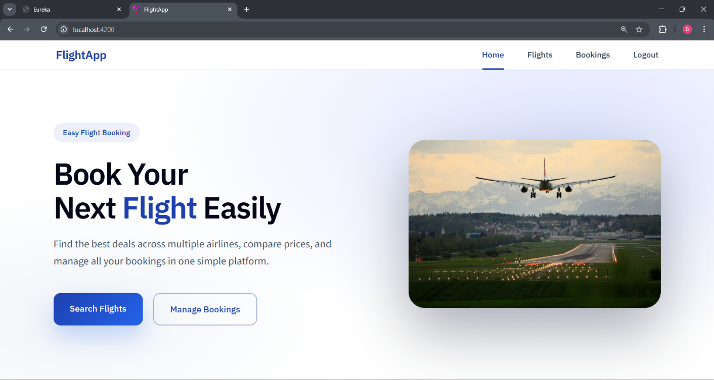

* Search Flights

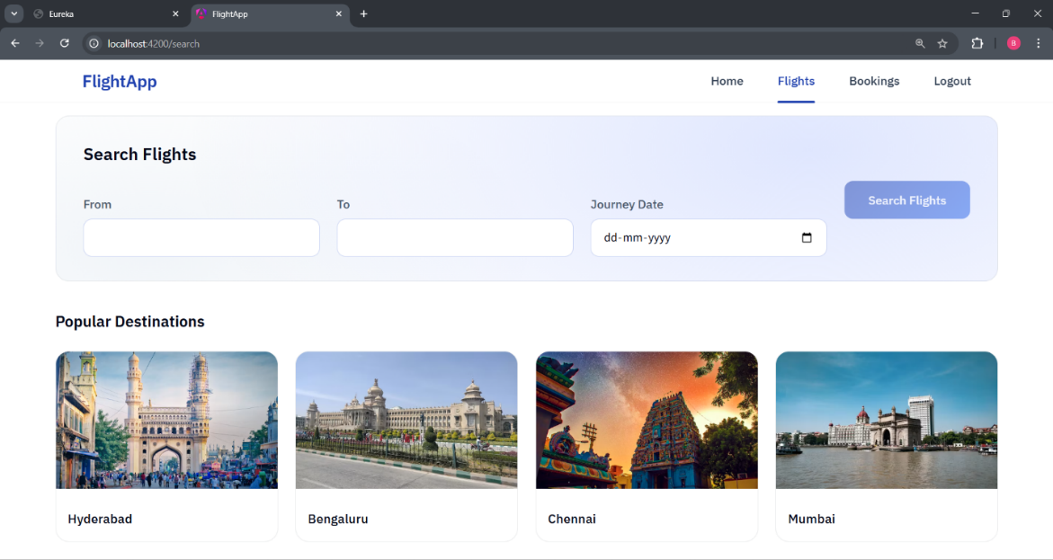

* Search Flights Results

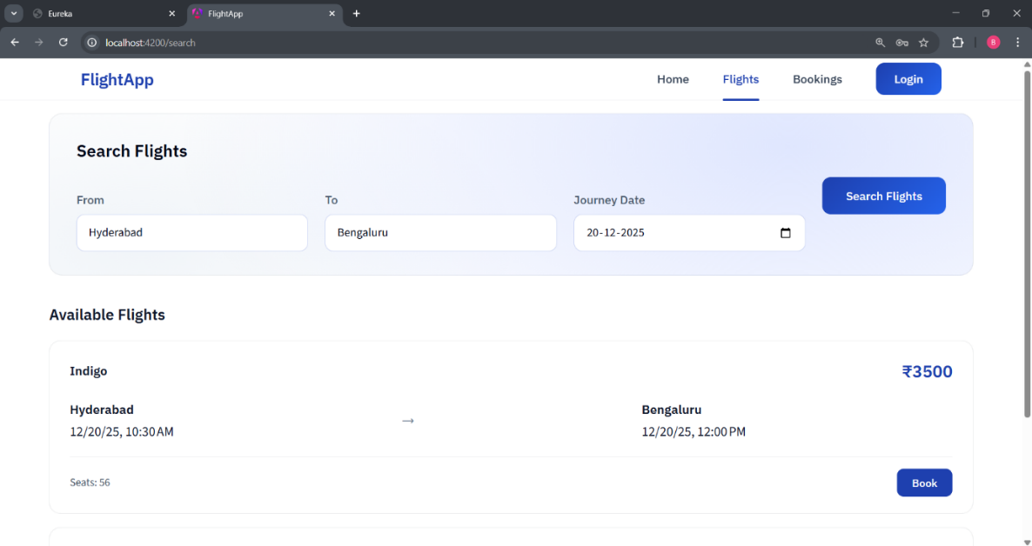

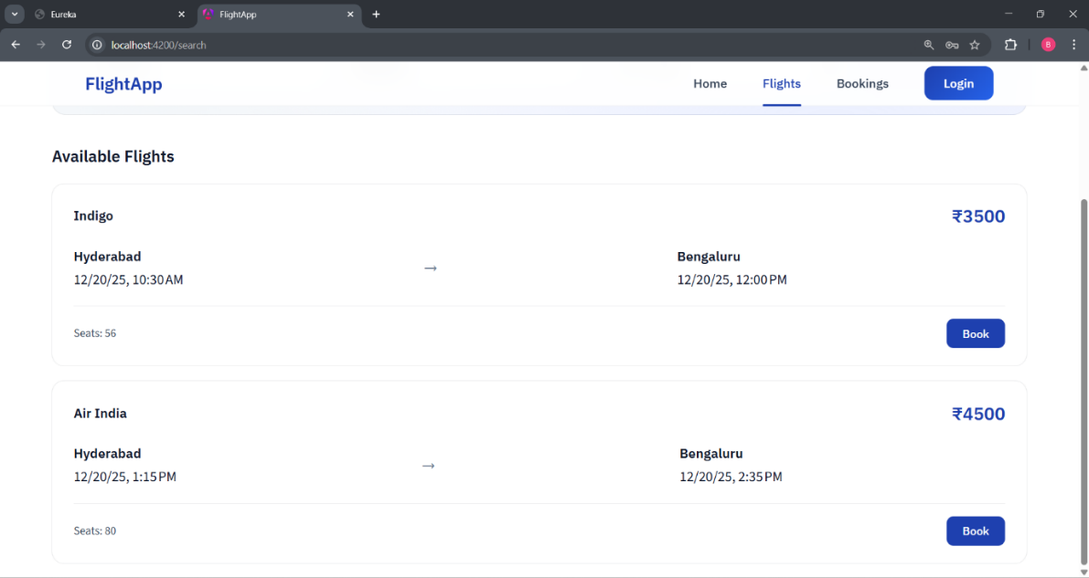

* Admin Dashboard

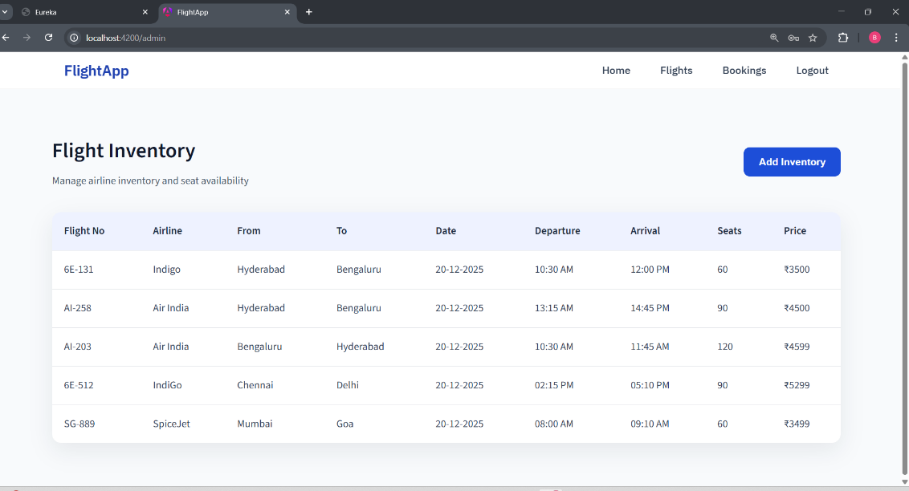

* Add Inventory
  + Success

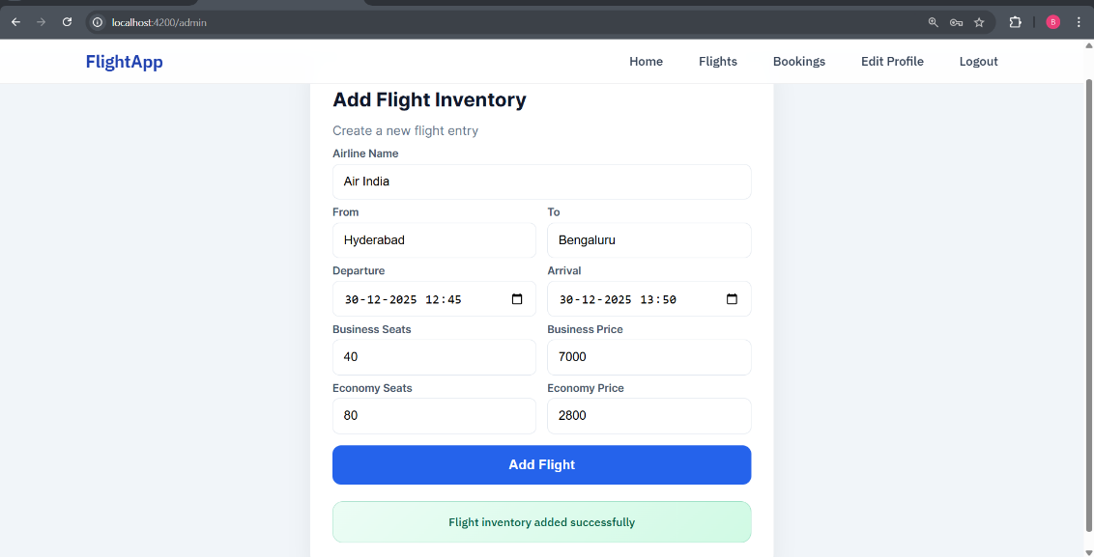

* + Error

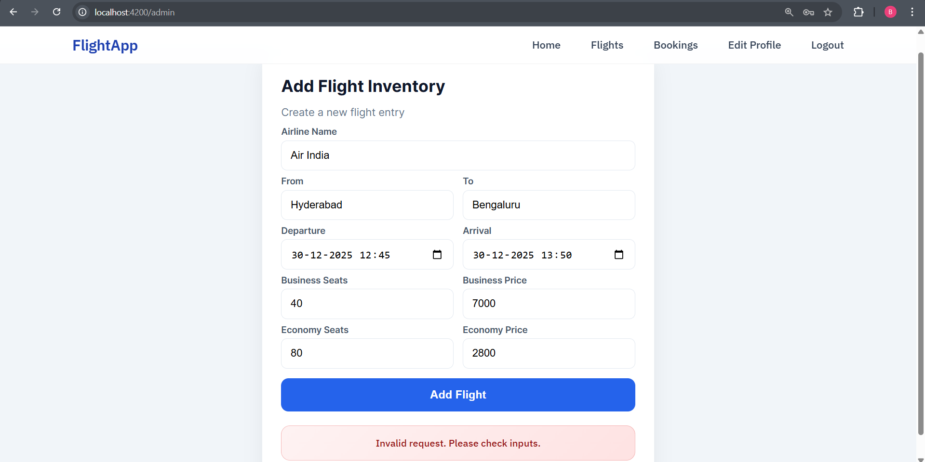

* User Dashboard

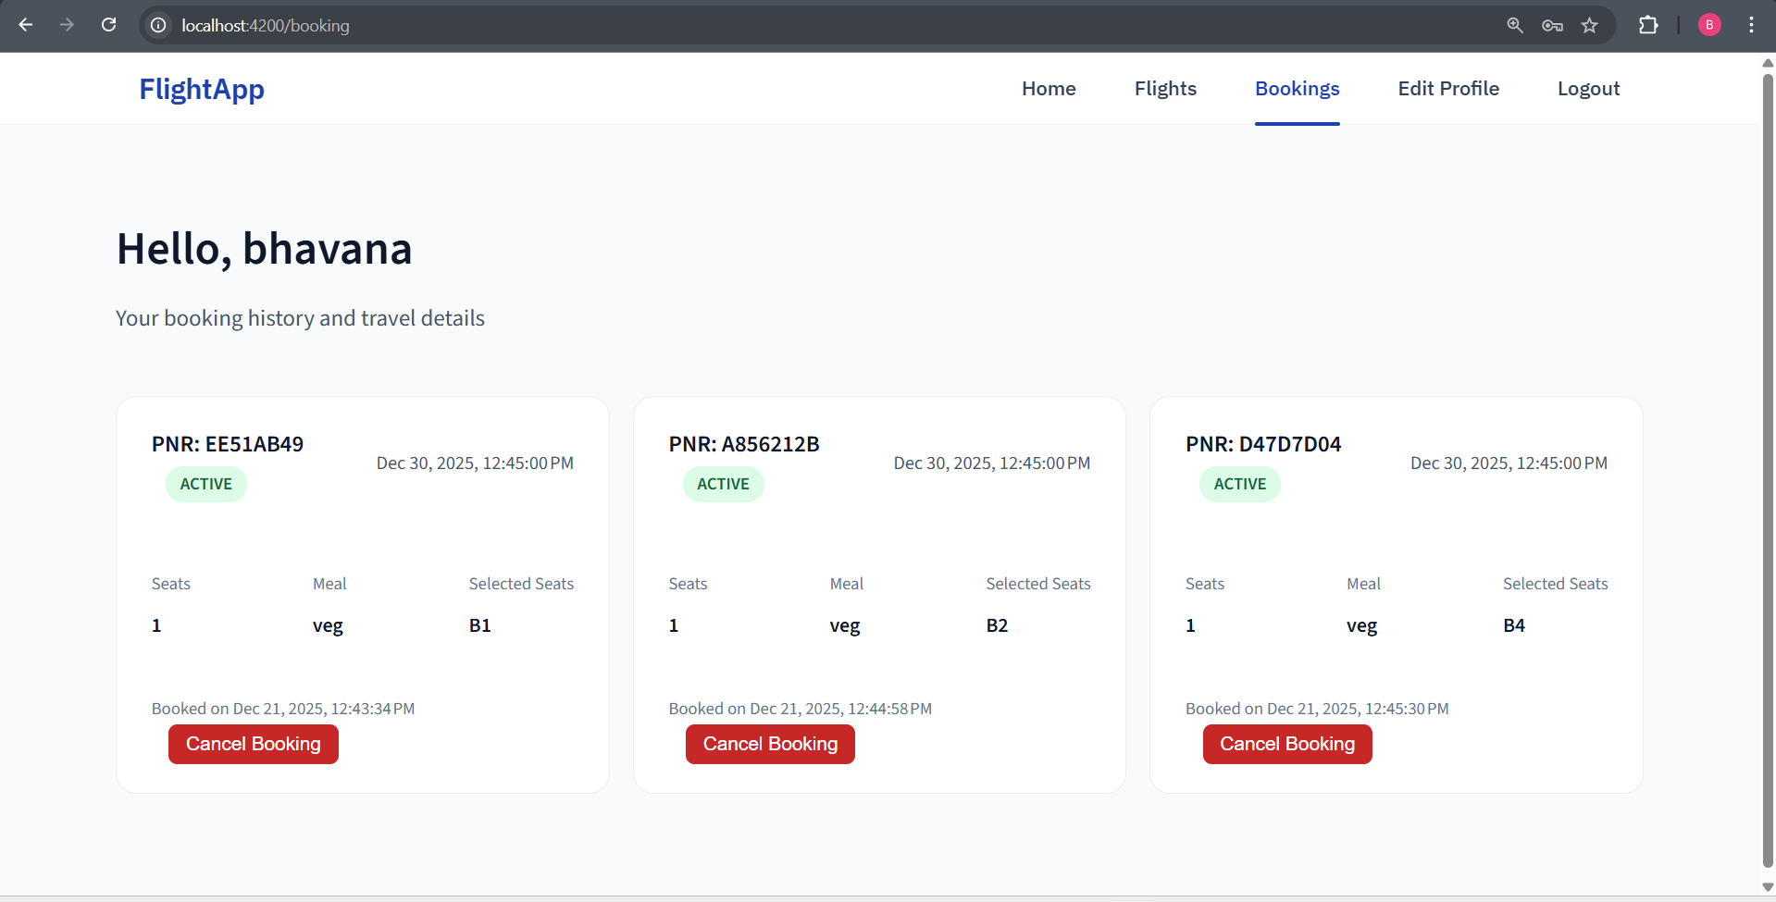

* Booking

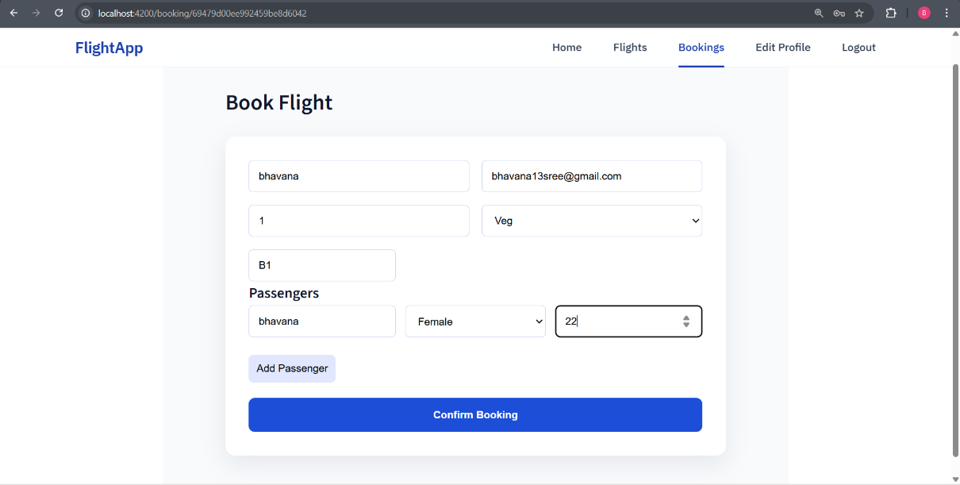

* Change password

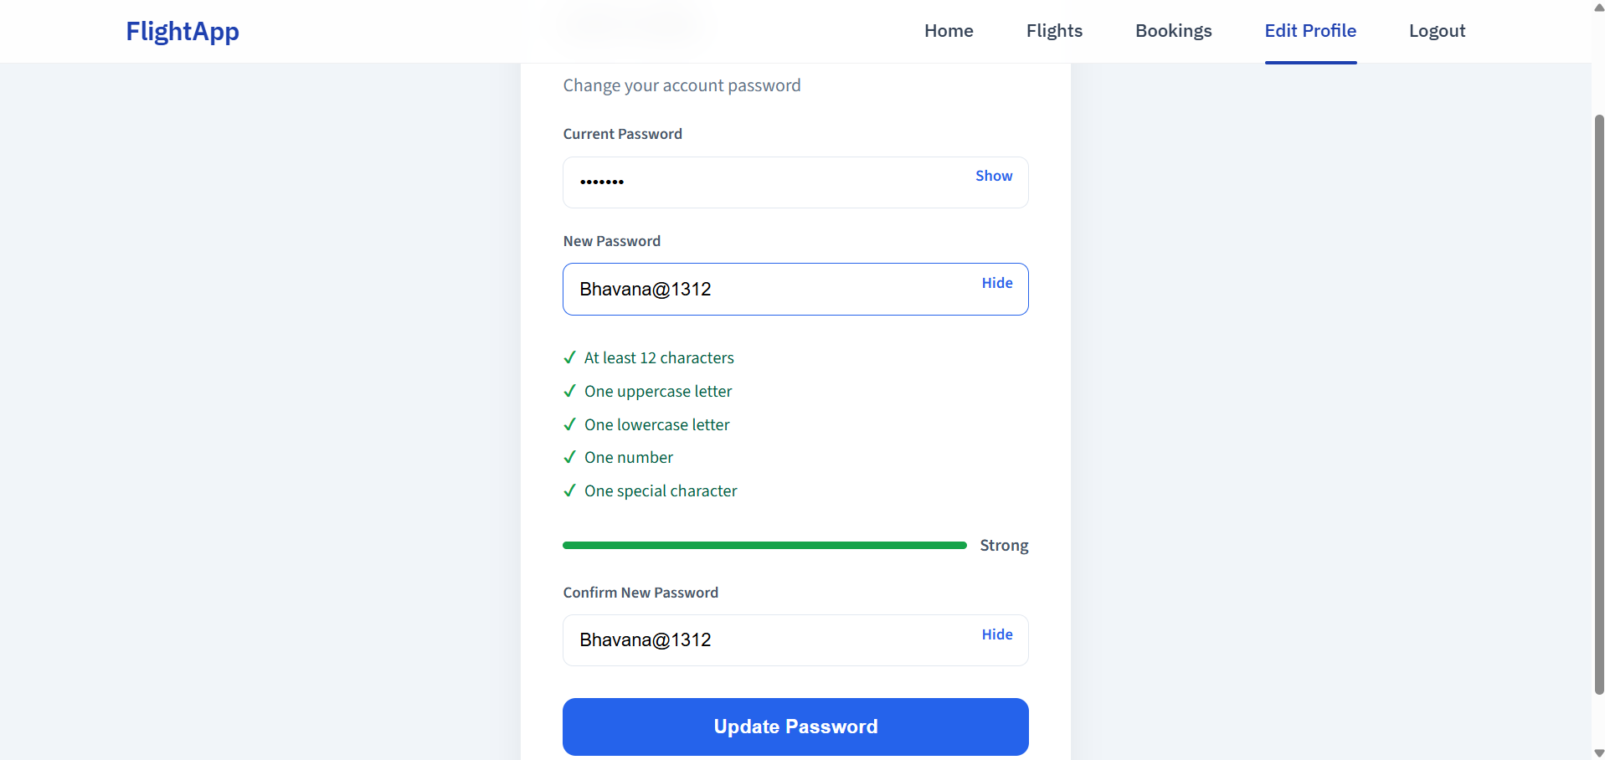

* Password Validations
  + At least 12 characters long

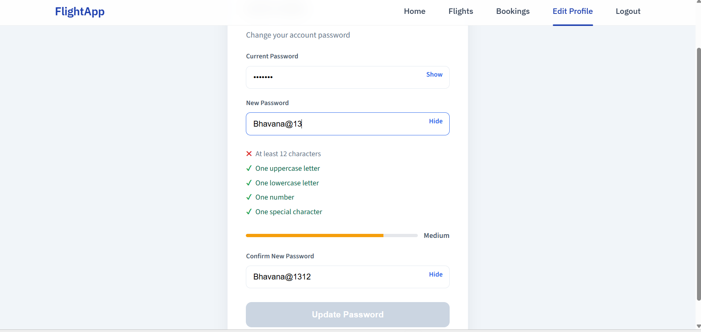

* + At least one upper case letter, one lower case letter, one digit, one special character

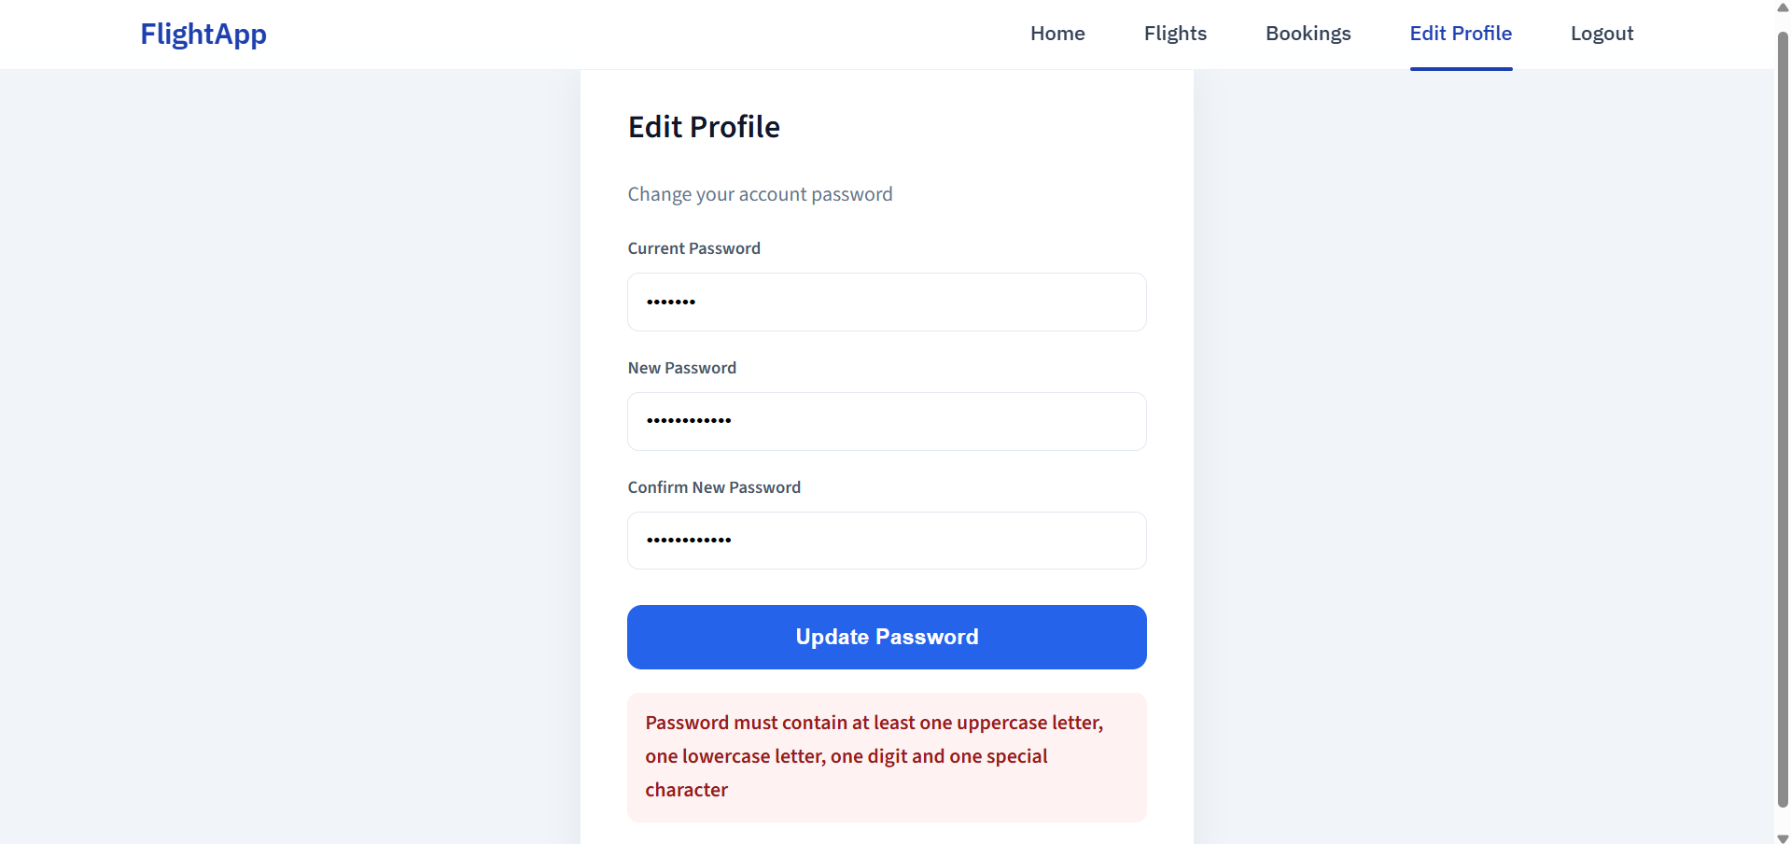

* + New password and confirm password should match

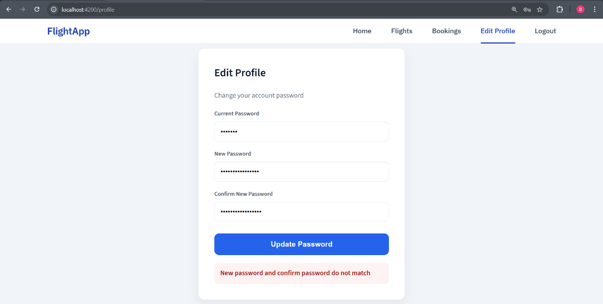

* Cancellation

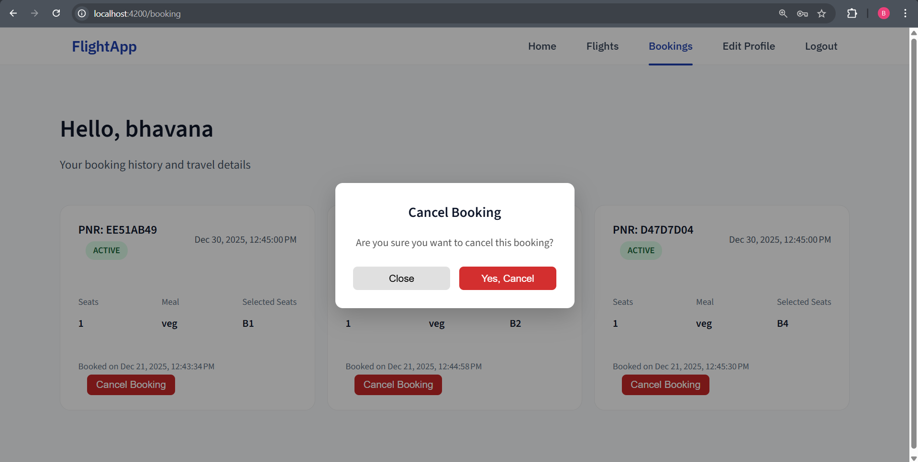

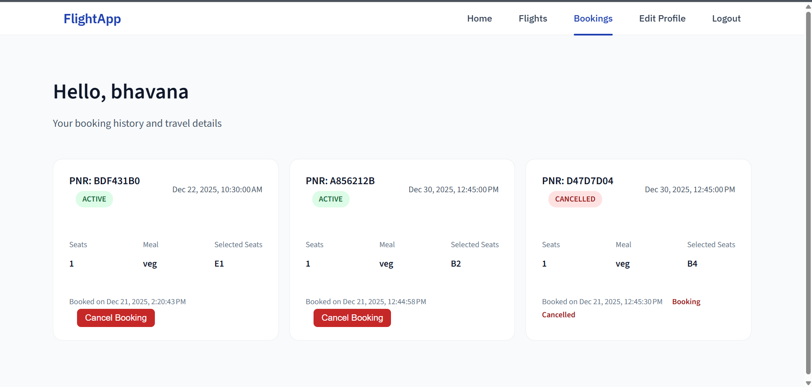

* Cancellation fails within 24 hrs of journey

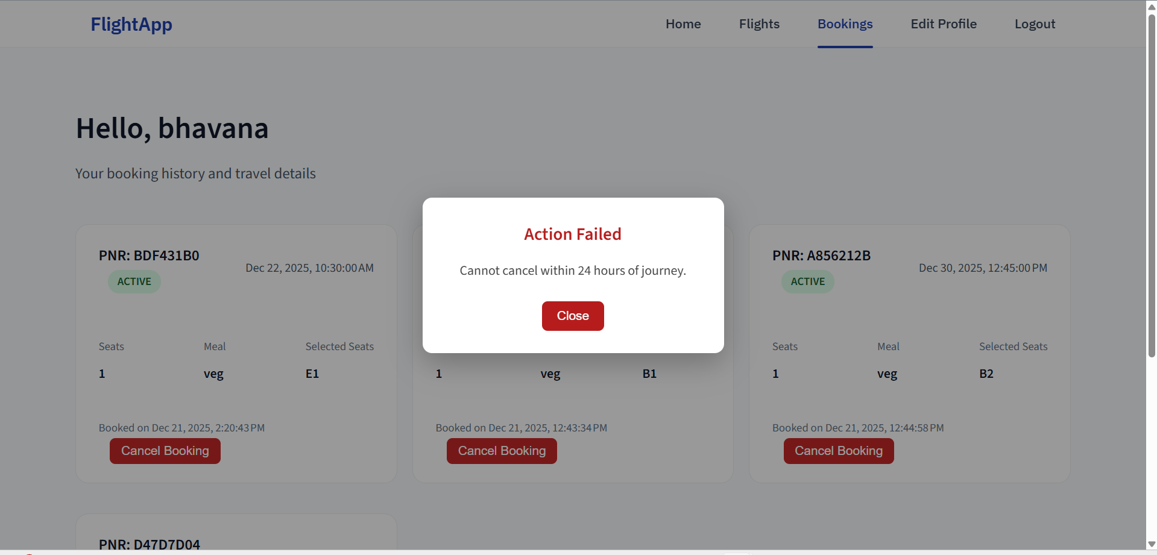

* Register

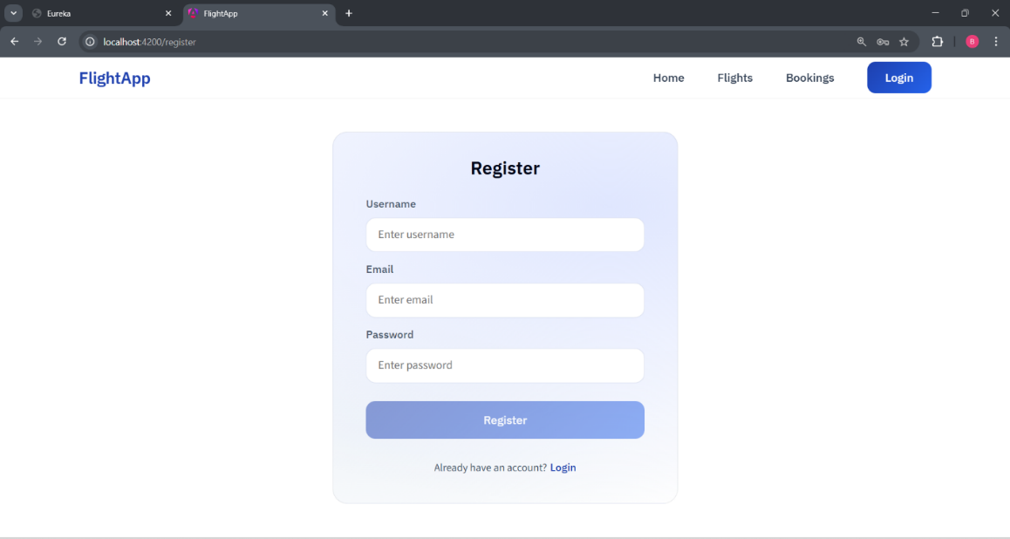

* Login

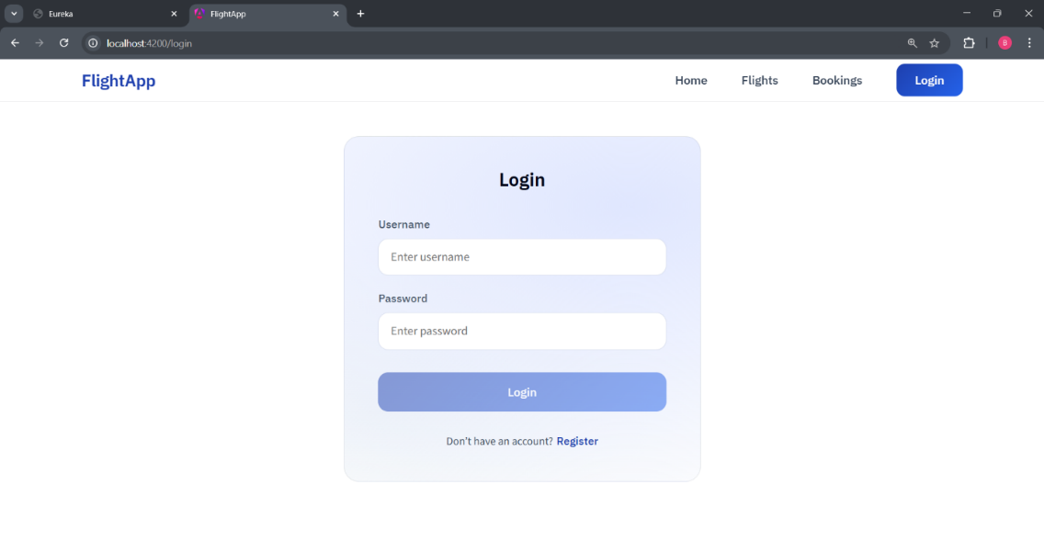

* Logout

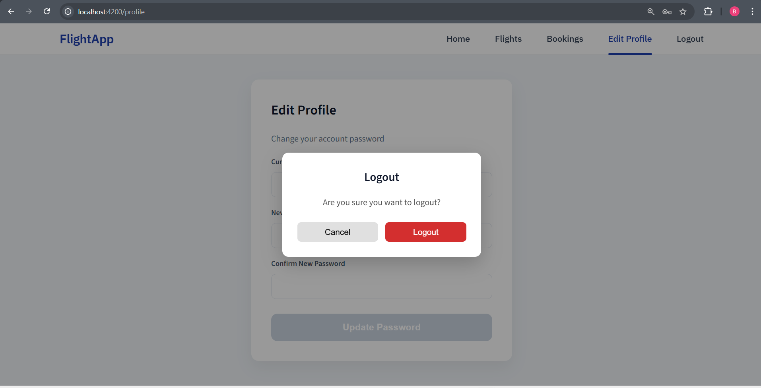

* Validations
* Invalid username or password - Login

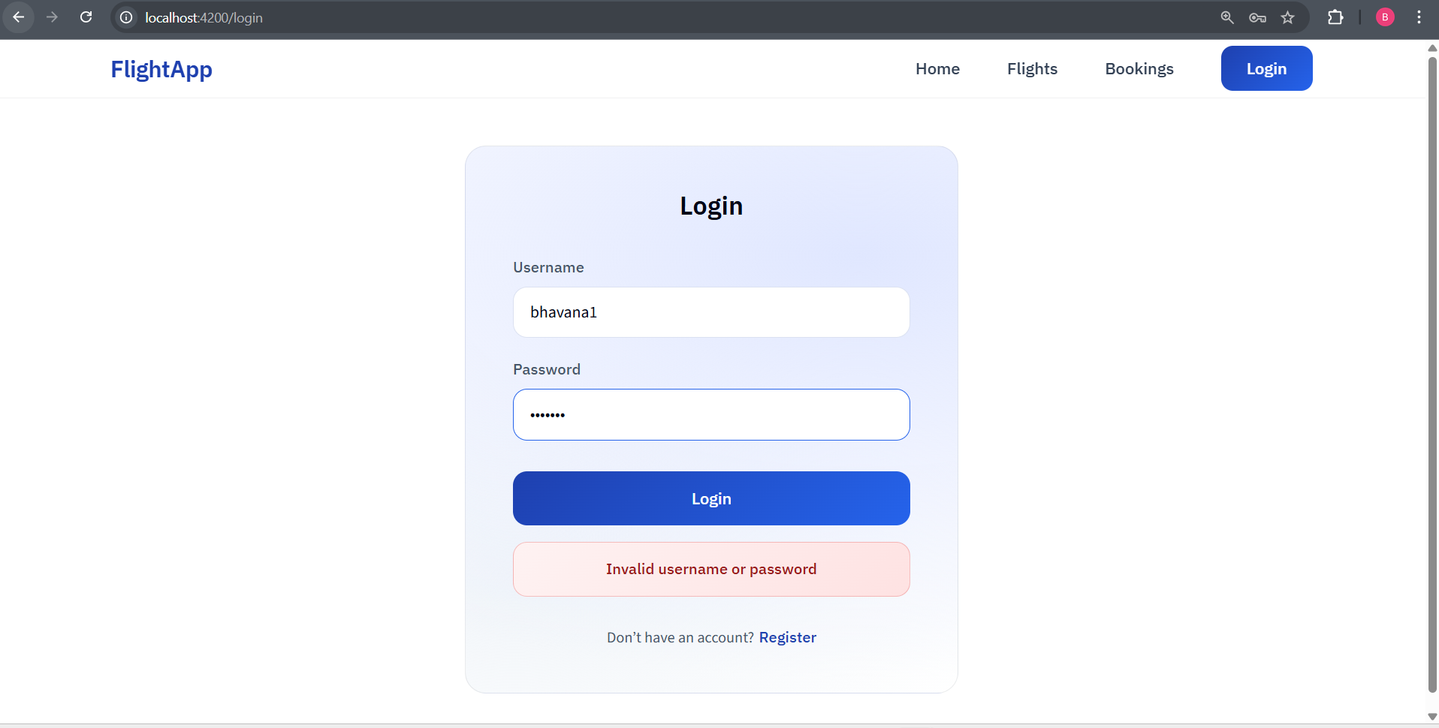

* Username already taken - Register

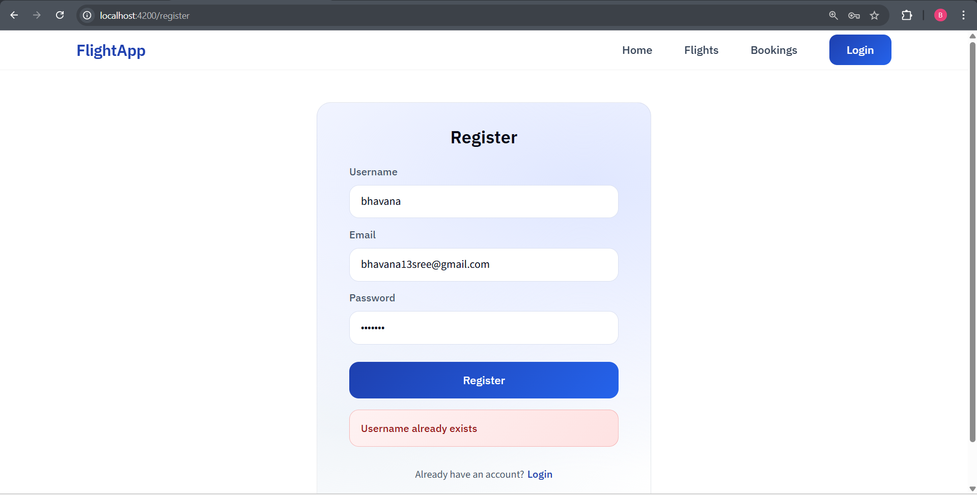

* Email already in use - Register

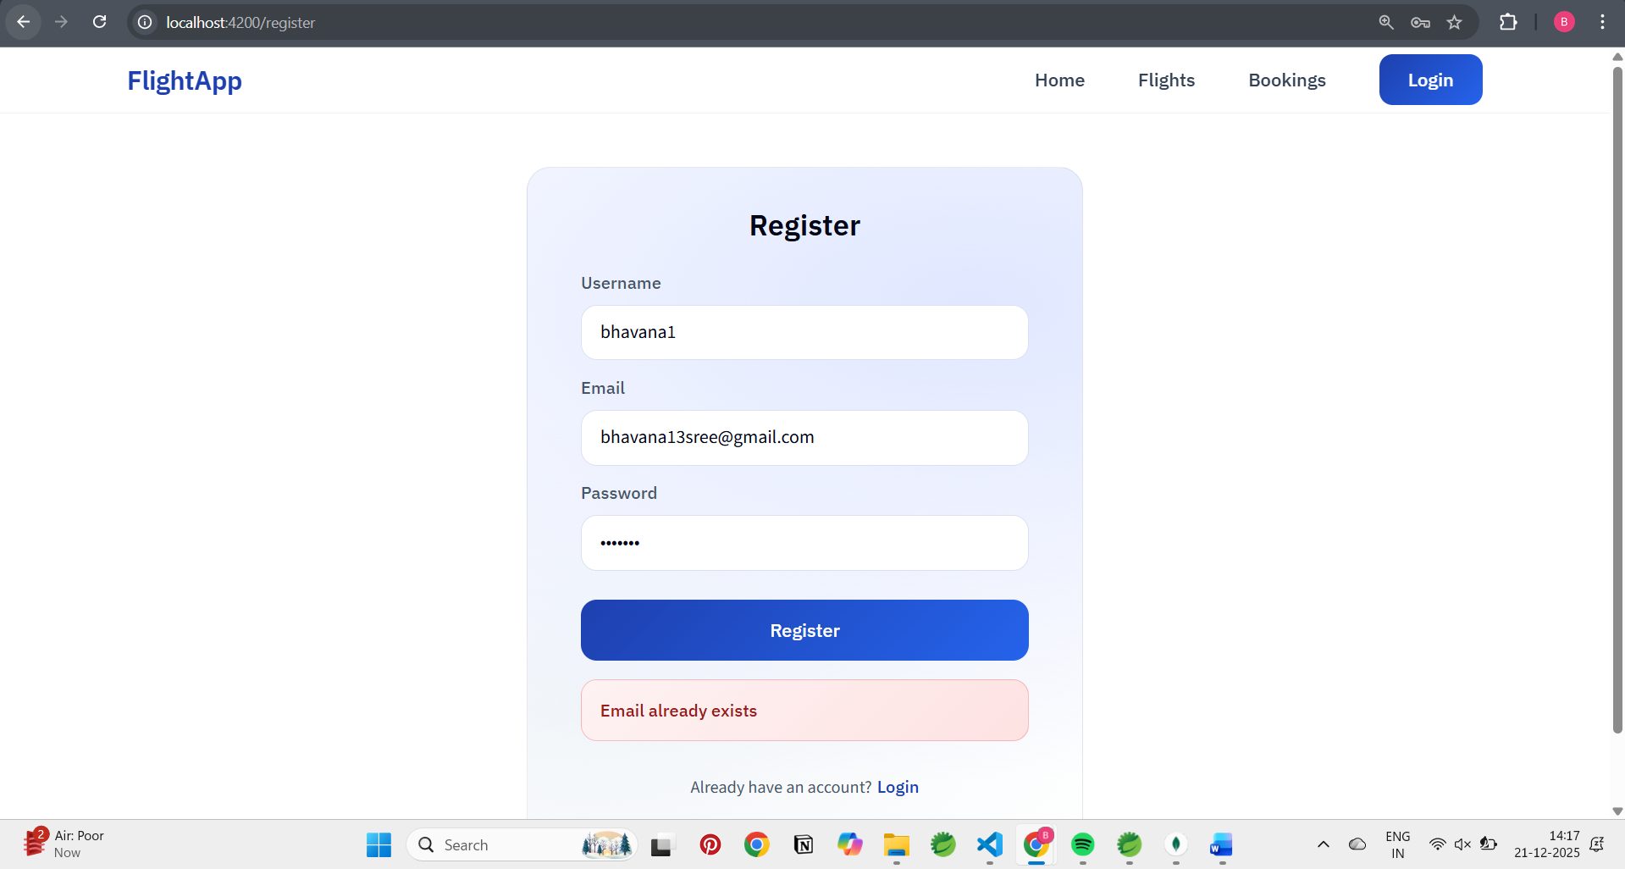

**System Architecture**

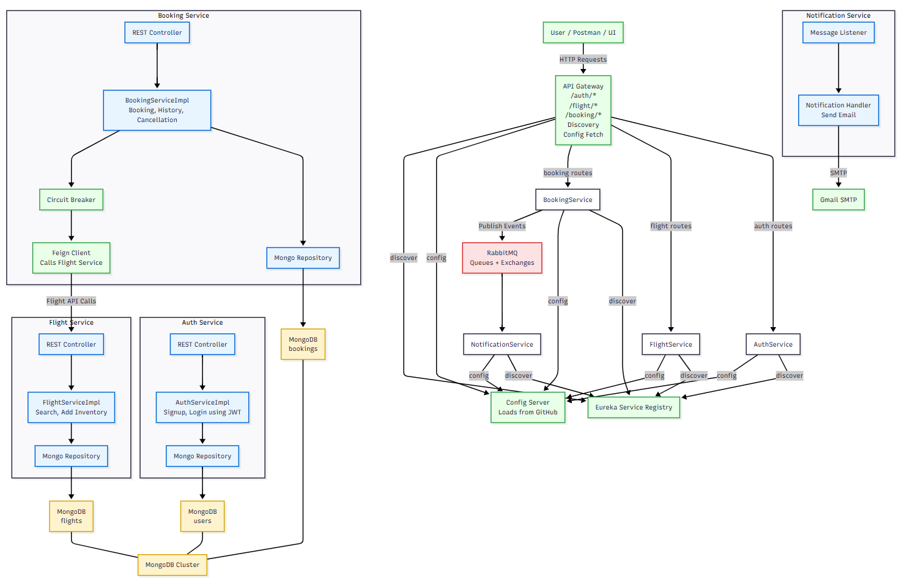

**Eureka Dashboard**

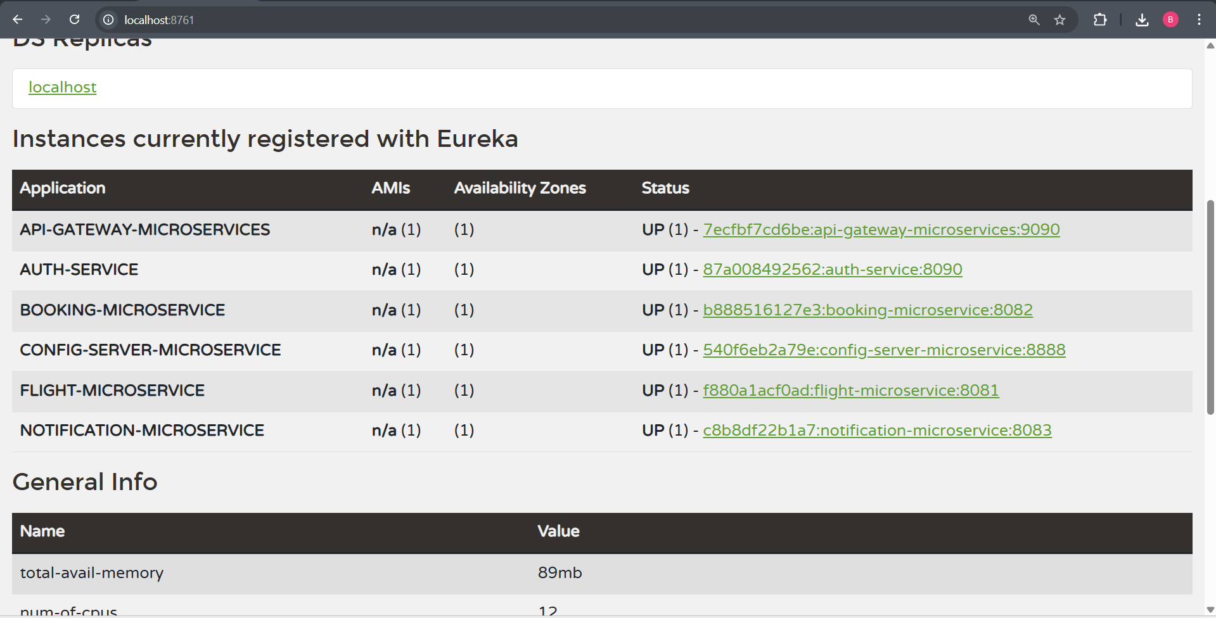

**Docker**

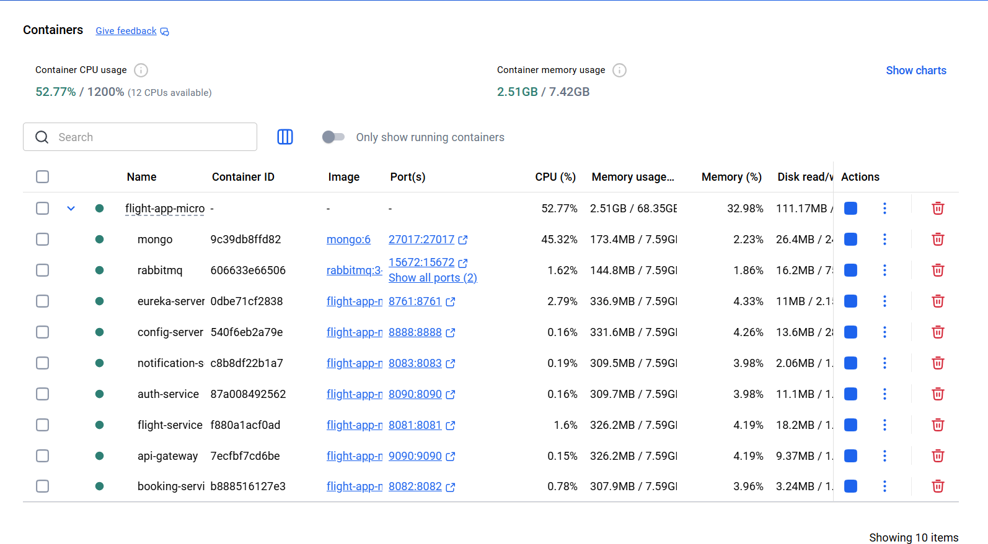

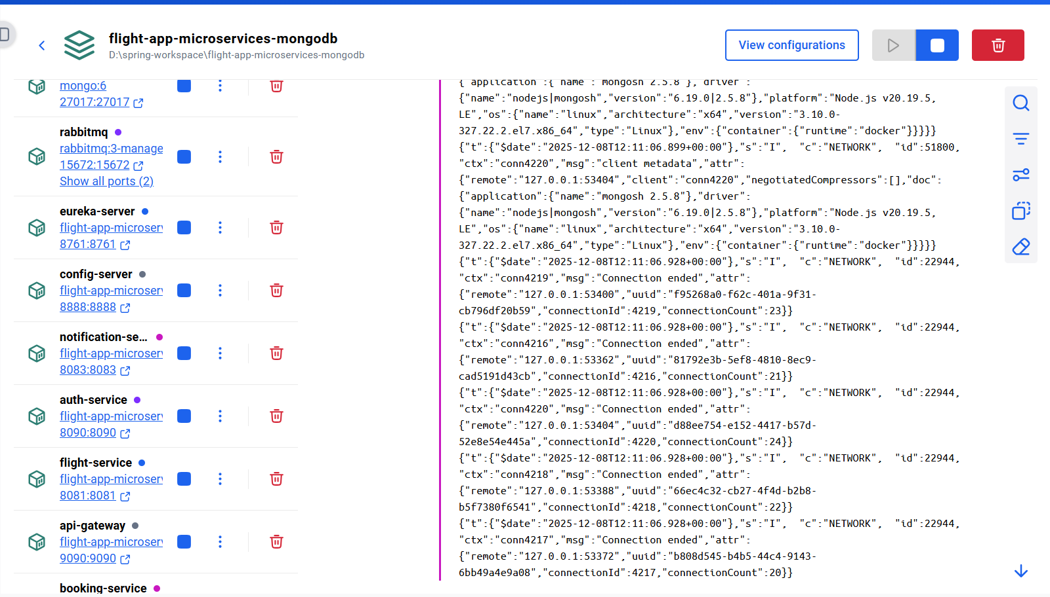

**MongoDB Screenshots**

* Roles in authdb

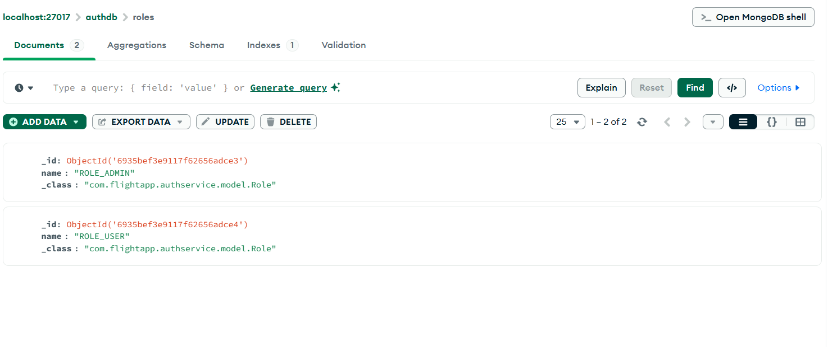

* Users in authdb

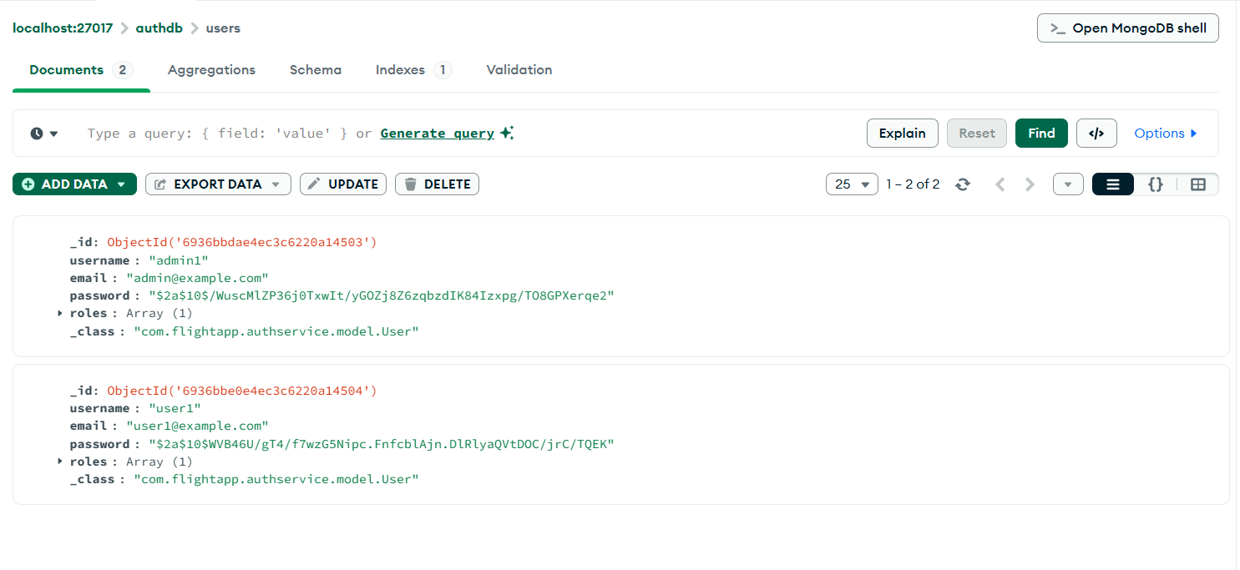

* Bookings in bookingdb

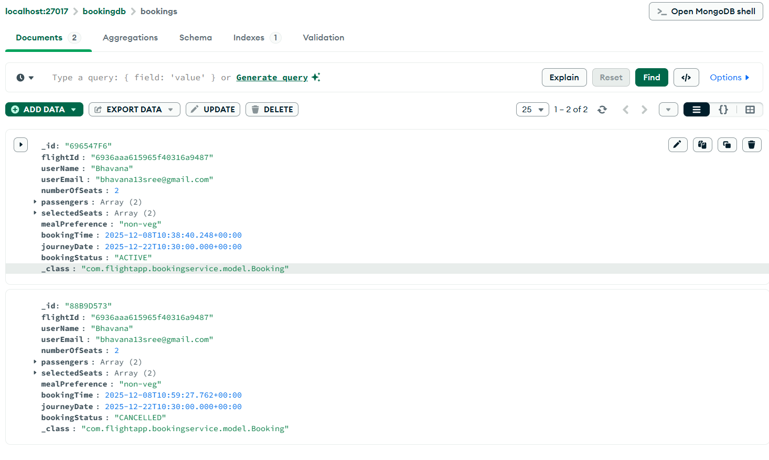

* Flights in flightdb

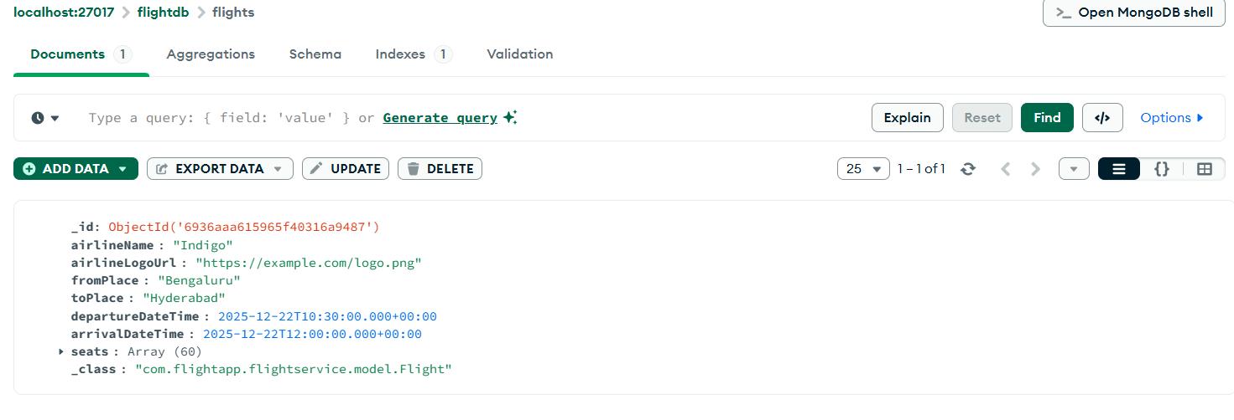

**Postman Screenshots**

* Admin signup

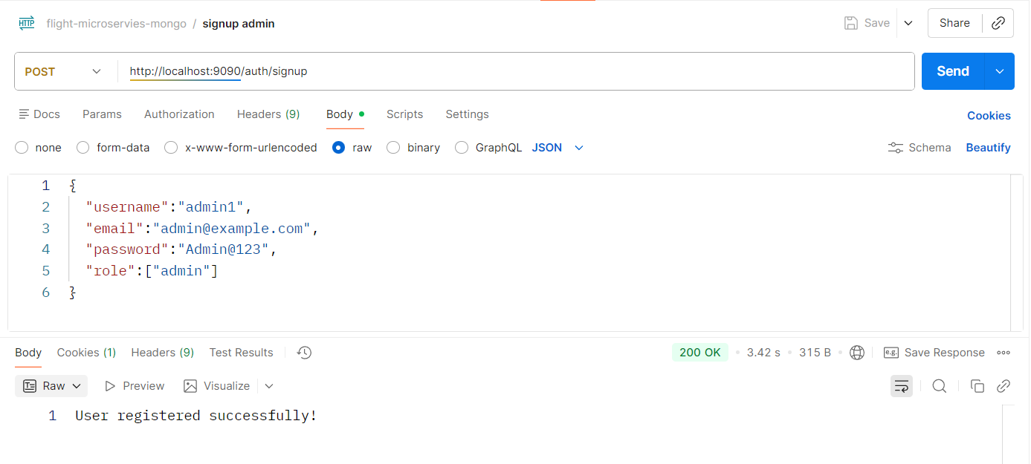

* Admin sign in

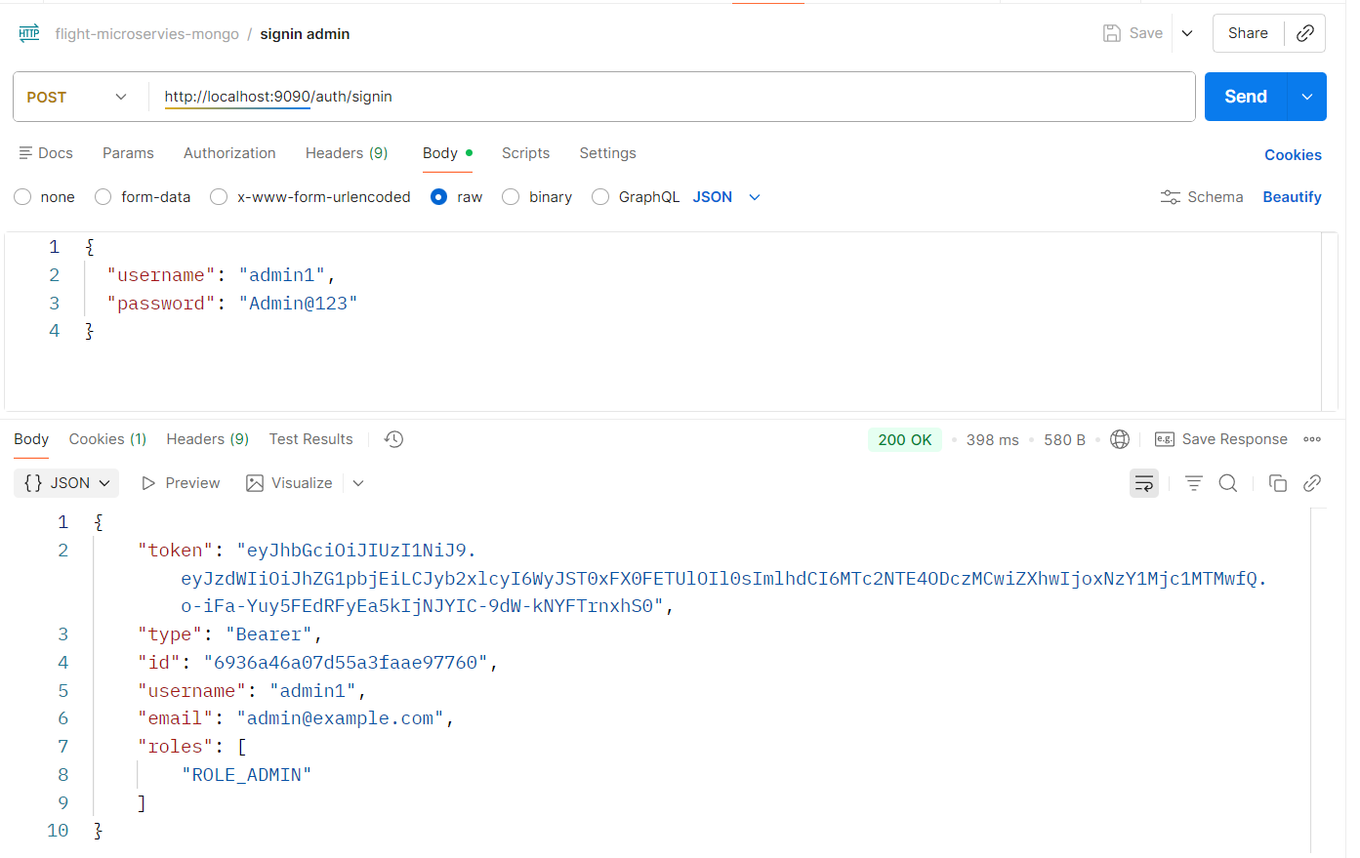

* Add Inventory – admin route

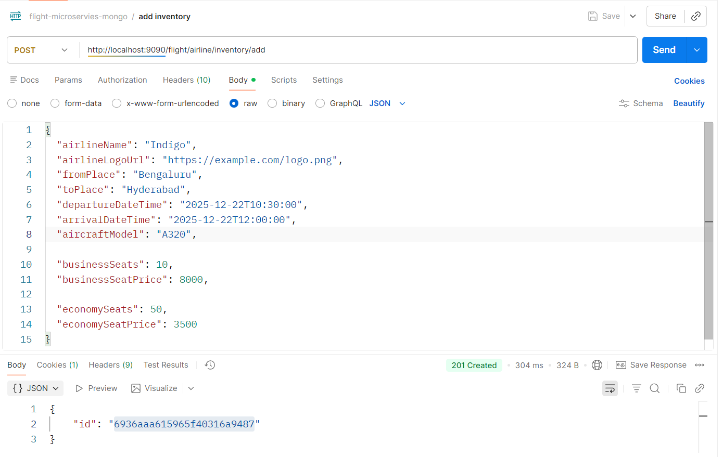

* User signup

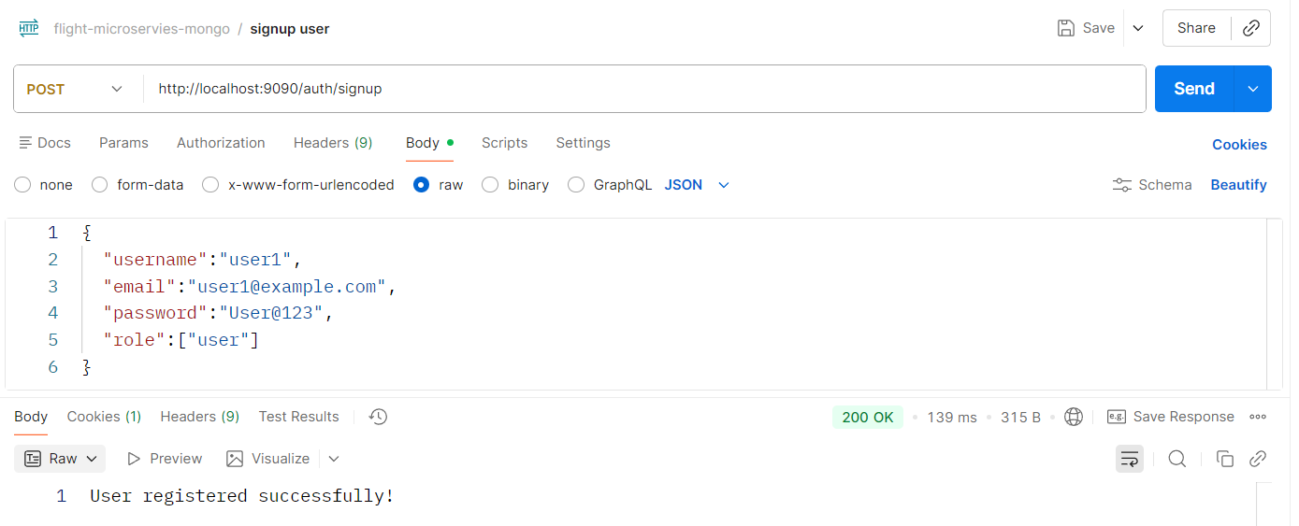

* User sign in

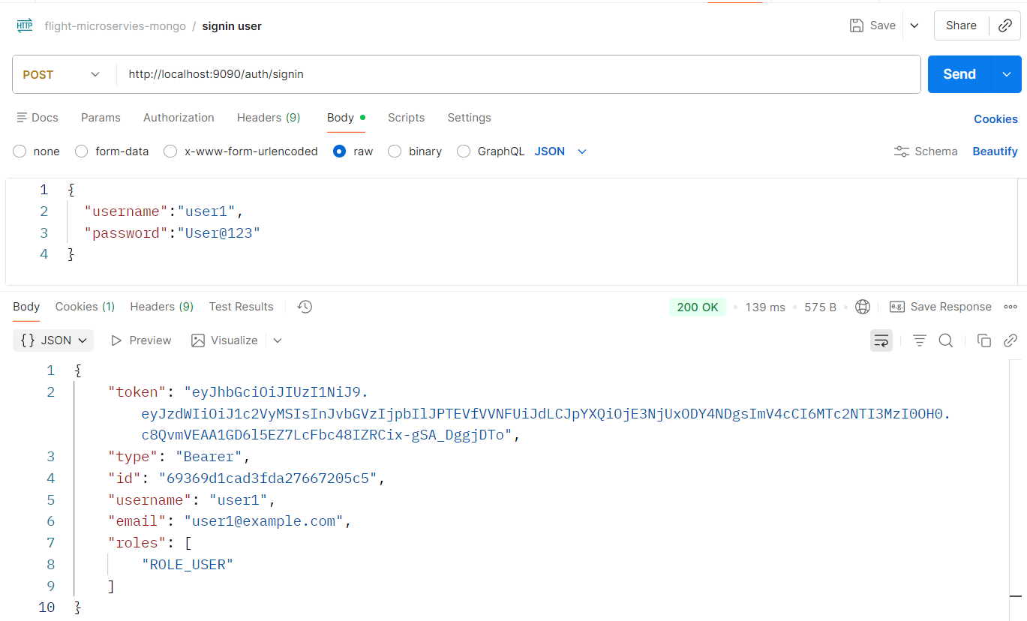

* Cancel ticket – user route

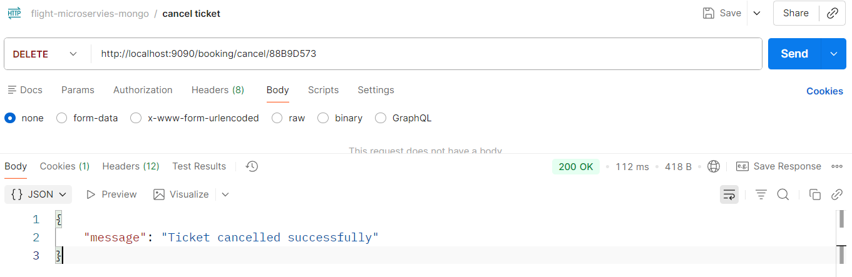

* Book flight – user route

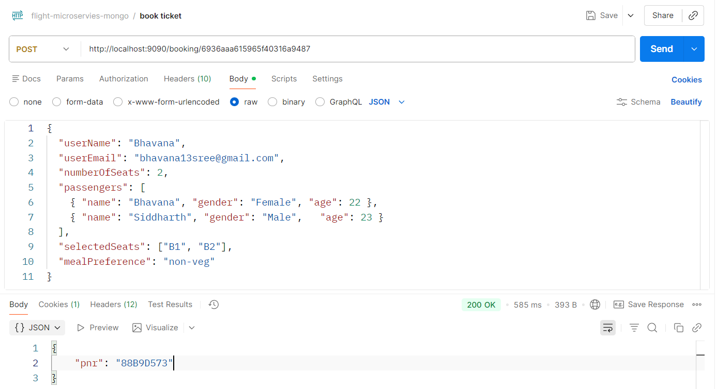

* Get history using email – user route

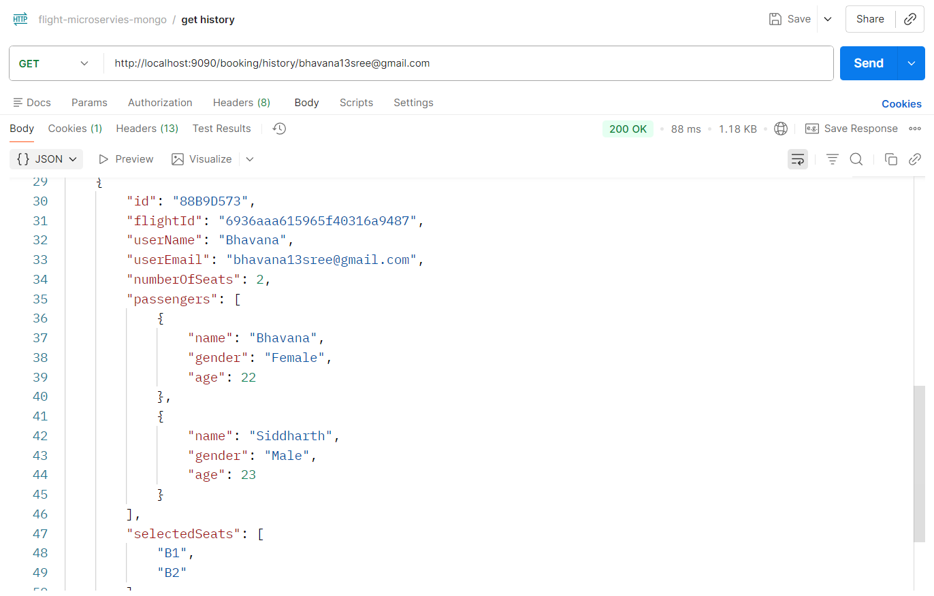

* Get ticket by PNR – user route

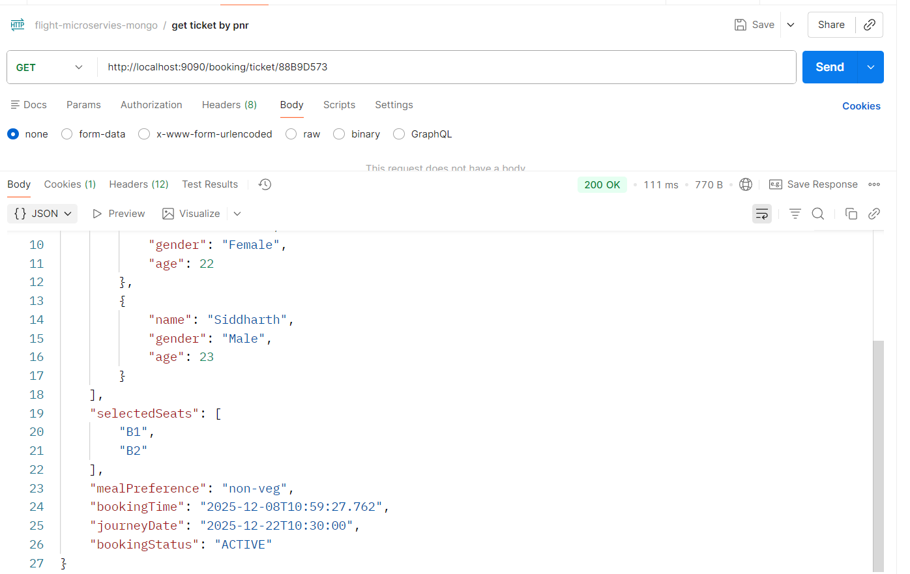

* Search Flight – user route

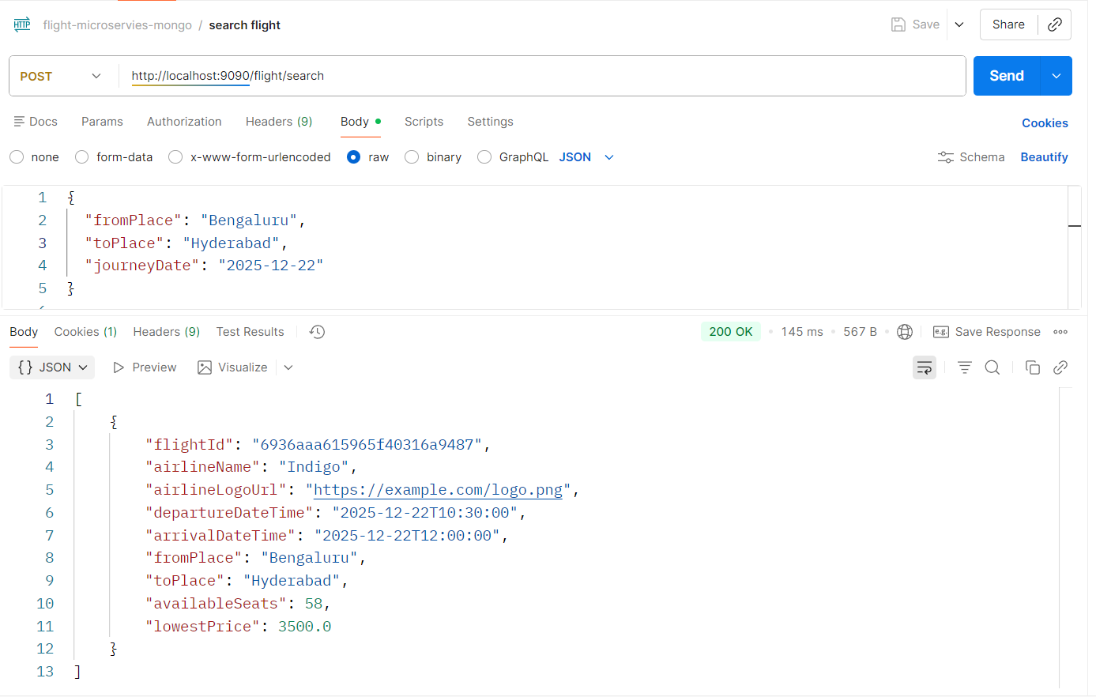

**Email Notification**

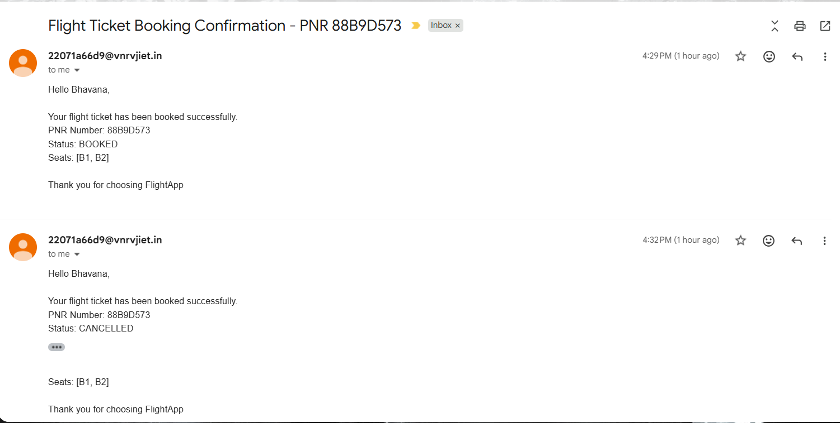

**Message broker – RabbitMQ**

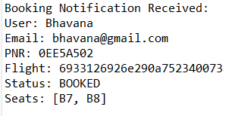

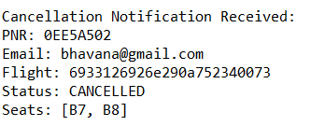

**Sonarqube**

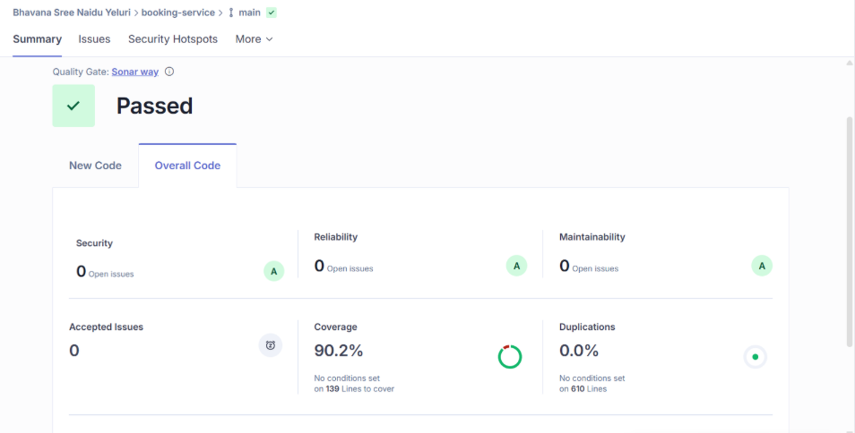

**Jacoco**

* + **95% coverage**

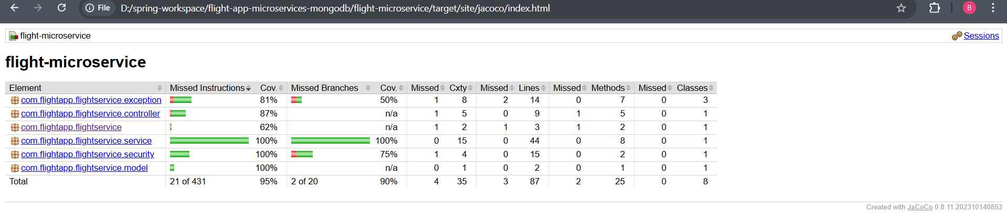

**Jmeter**

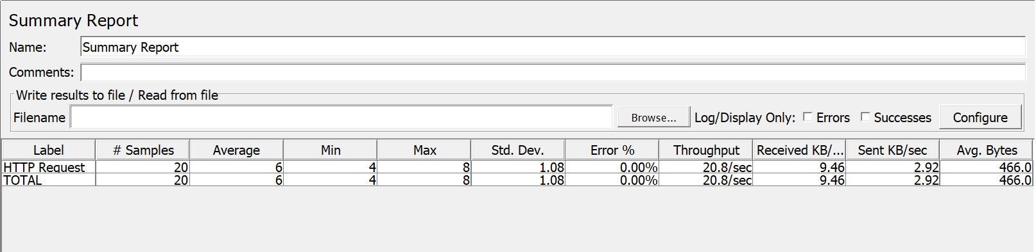

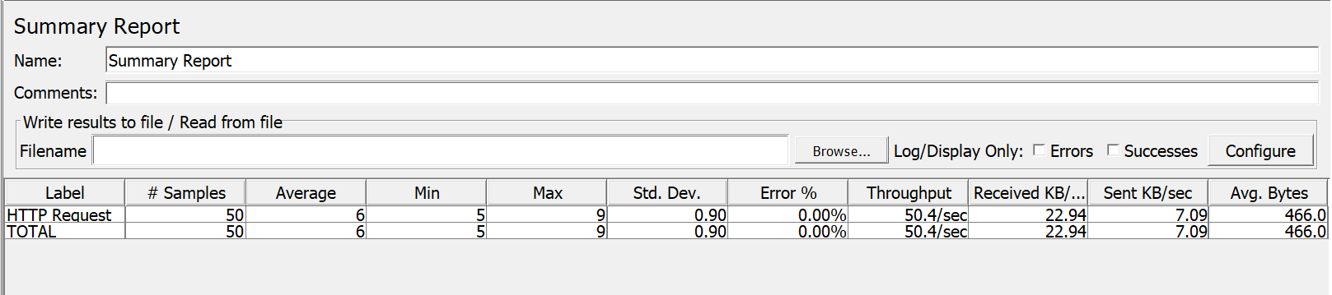

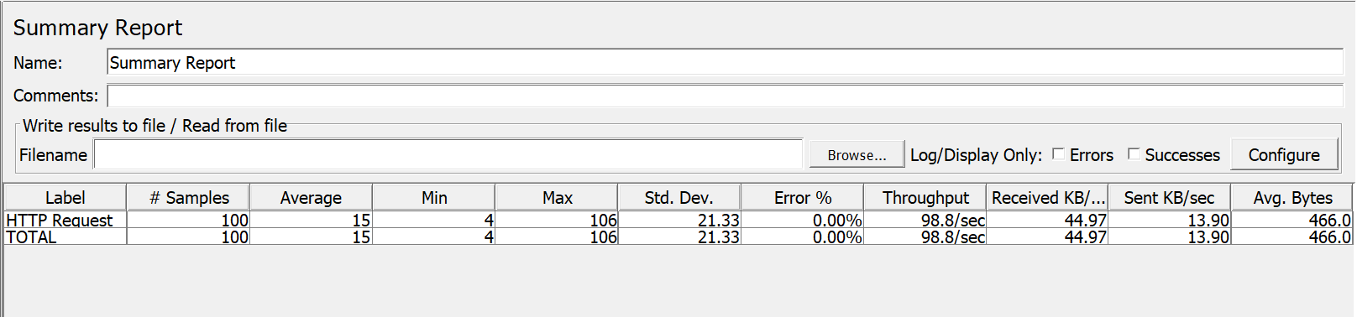

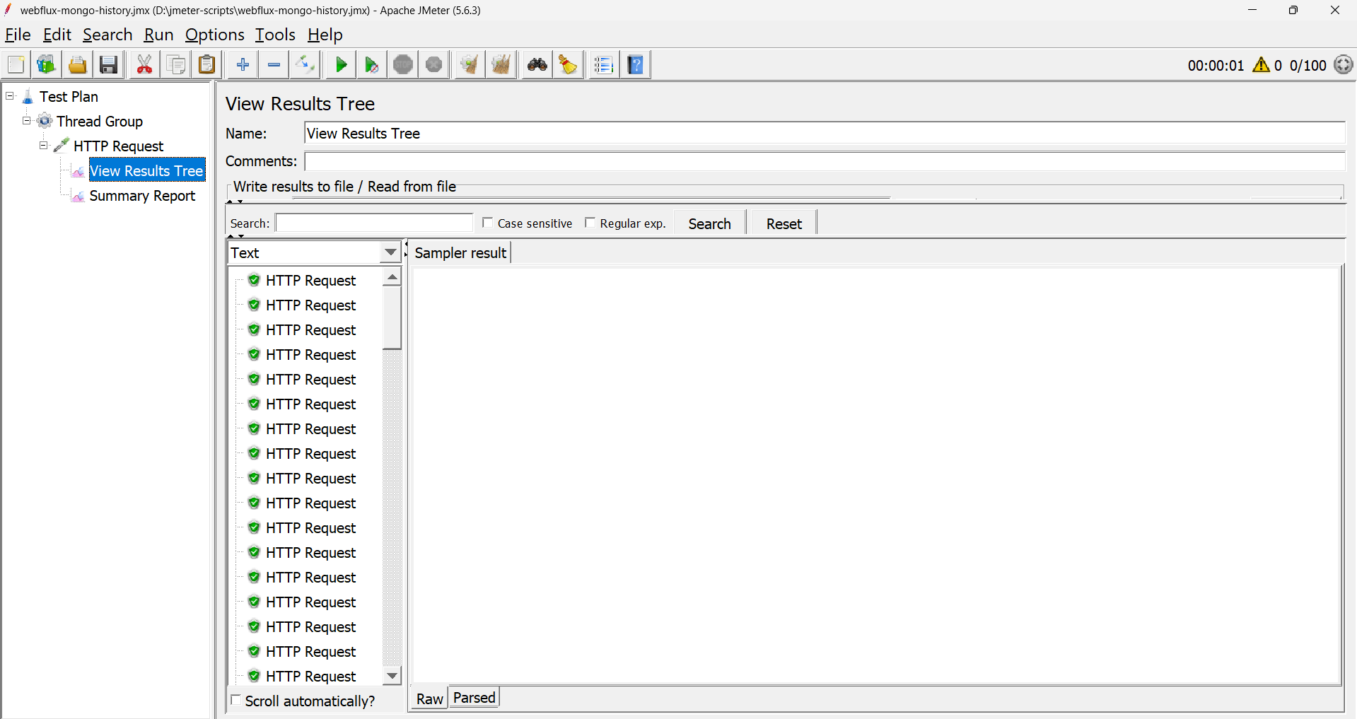

**Newman**

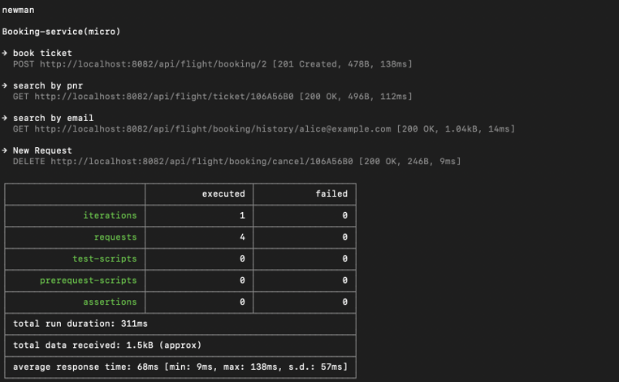

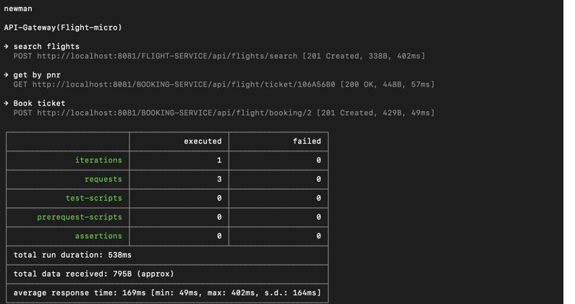

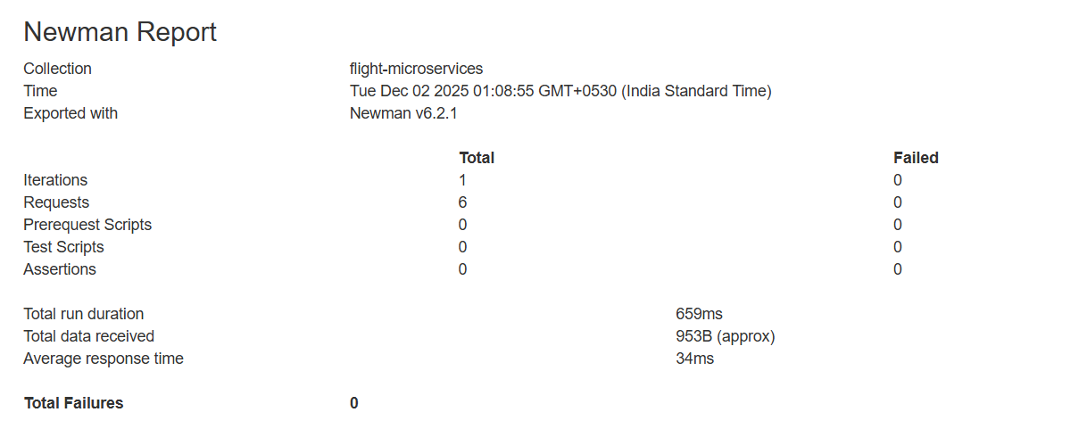

**Swagger**

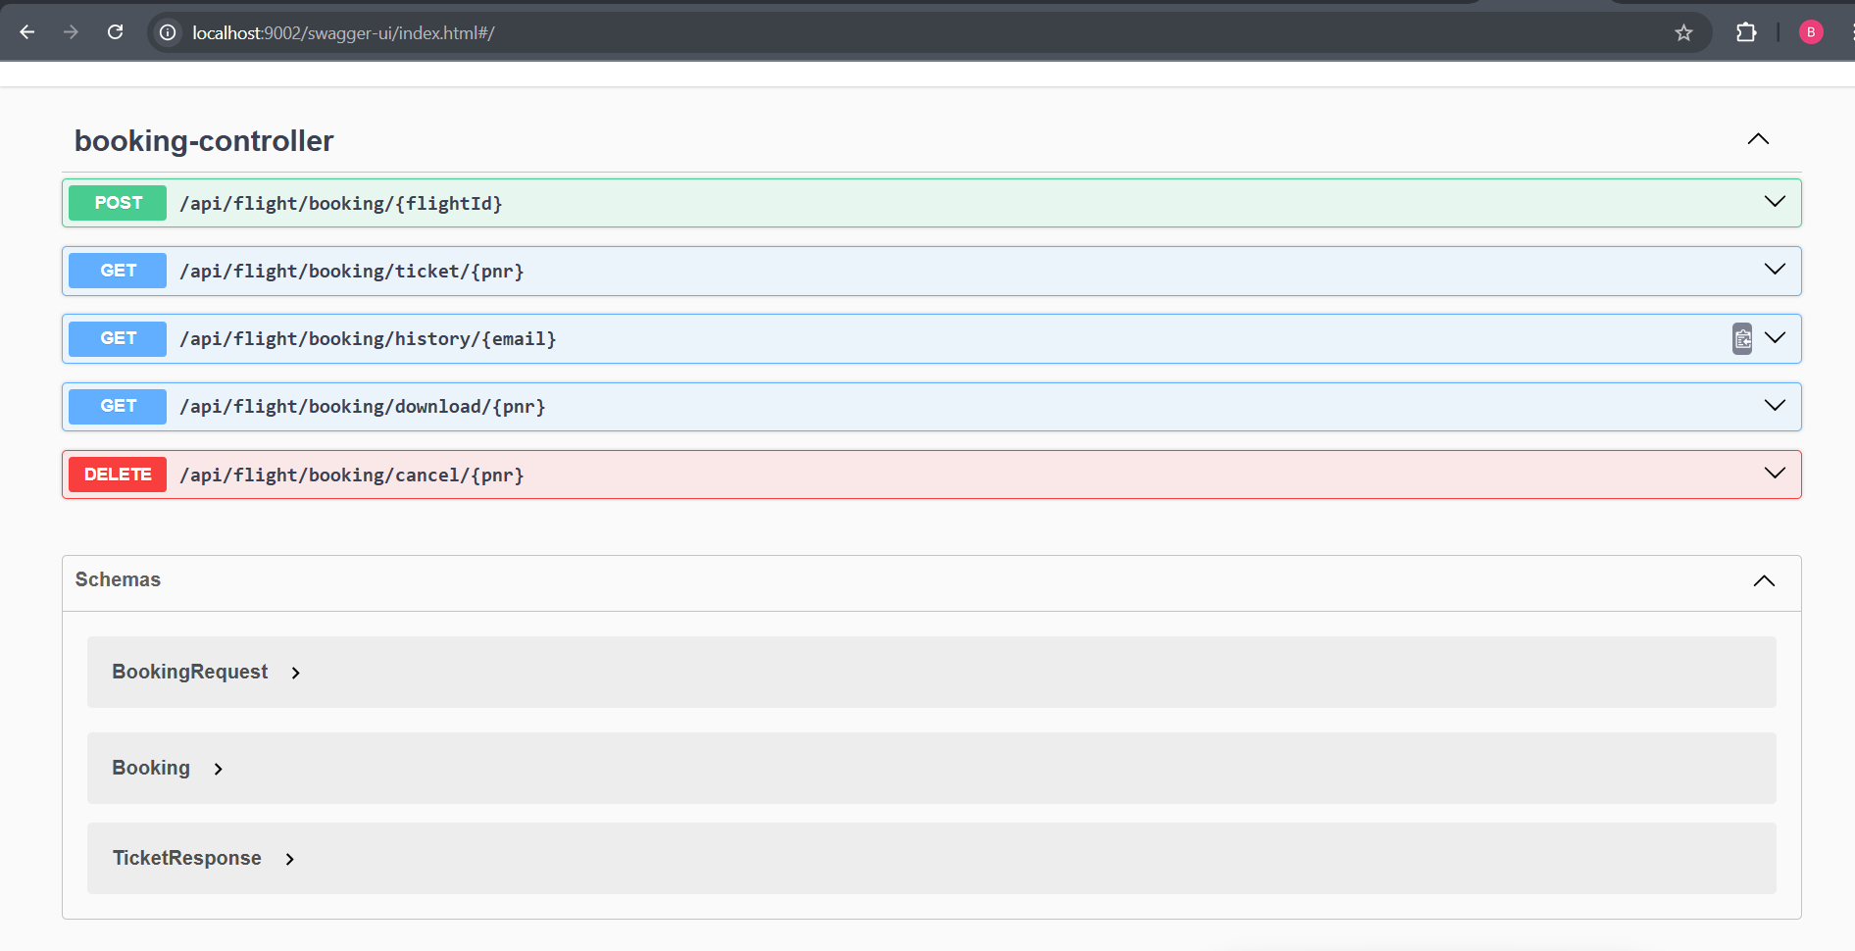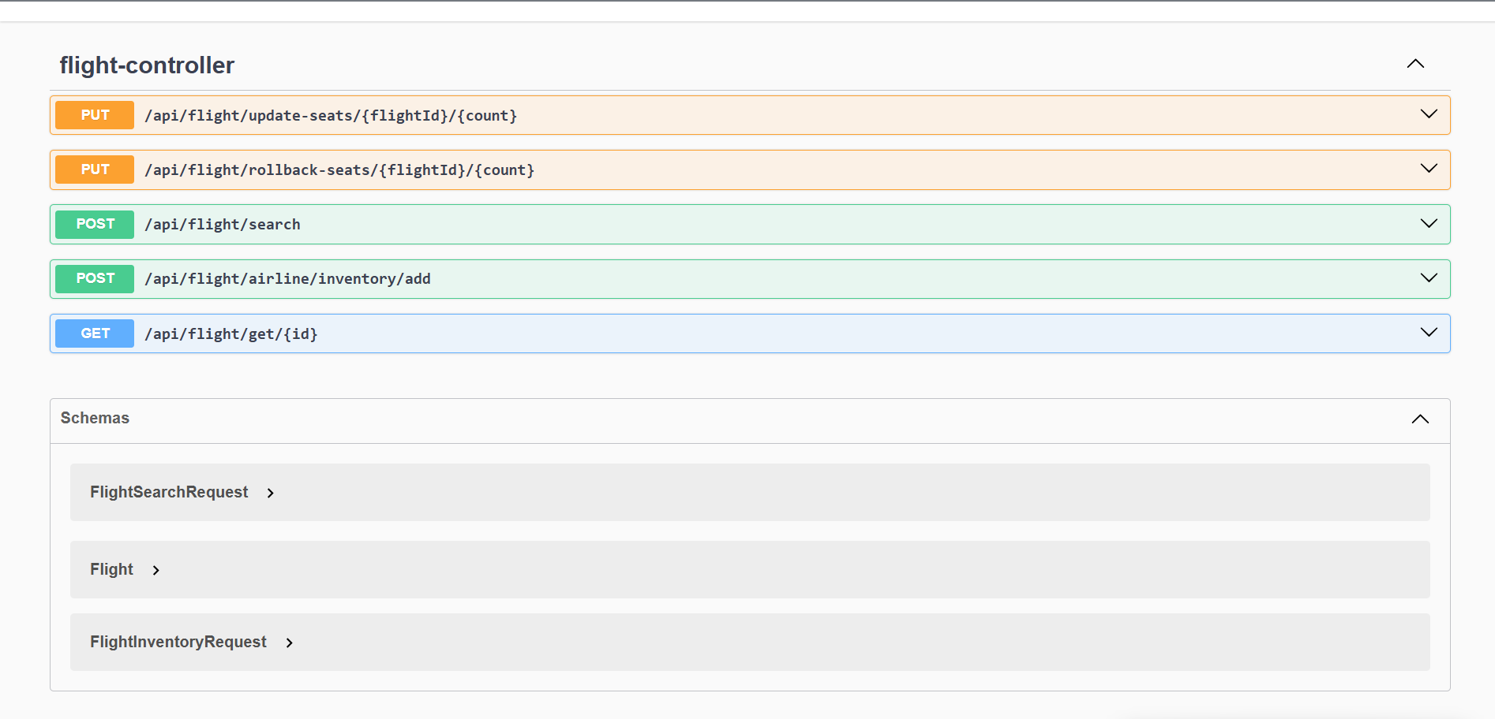

**Config Server**

